Week 4 task 7 and task 8
Task 7:
import java.io.*;
import java.util.*;

public class Solution {

public static void main(String[] args) {

Scanner sc = new Scanner(System.in);

int n = sc.nextInt();

int[][] arr = new int[n][n];

// Read matrix
for (int i = 0; i < n; i++) {
for (int j = 0; j < n; j++) {
arr[i][j] = sc.nextInt();
}
}

int primarySum = 0;
int secondarySum = 0;

// Calculate diagonal sums
for (int i = 0; i < n; i++) {

// Primary diagonal
primarySum += arr[i][i];

// Secondary diagonal
secondarySum += arr[i][n - 1 - i];
}

// Absolute difference
int difference = Math.abs(primarySum - secondarySum);

System.out.println(difference);

sc.close();
}
}
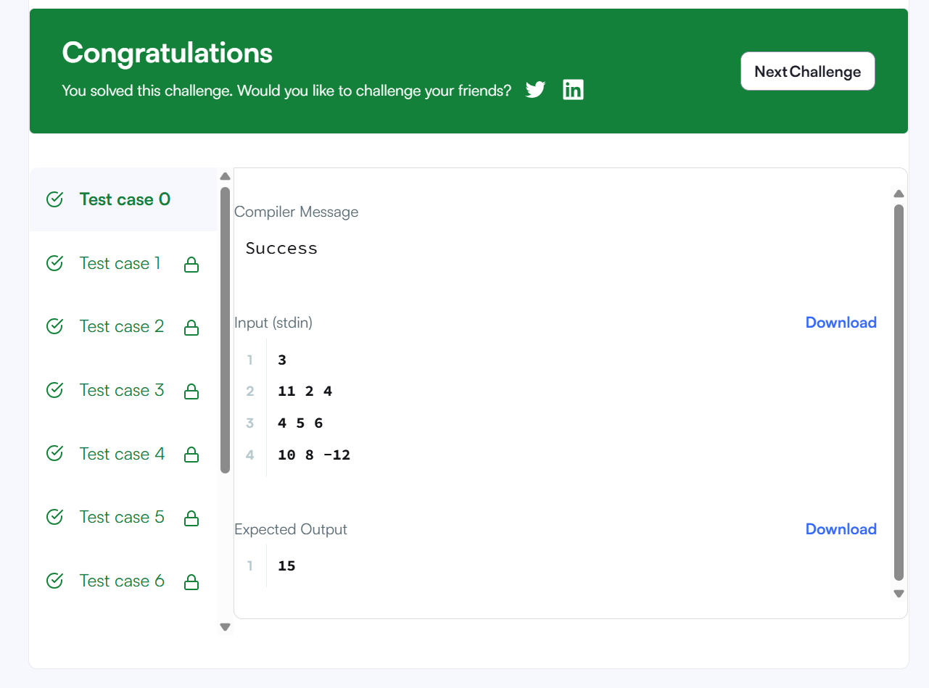
Task 8:
class Solution {
public int[][] transpose(int[][] matrix) {

int m = matrix.length; // number of rows
int n = matrix[0].length; // number of columns

int[][] result = new int[n][m];

for (int i = 0; i < m; i++) {

for (int j = 0; j < n; j++) {

result[j][i] = matrix[i][j];
}
}

return result;
}
}
